Java Installed
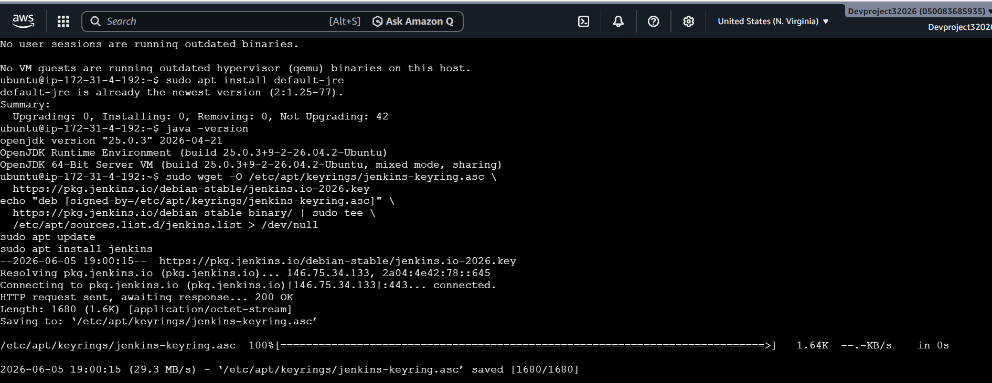
Jenkins installed successfully & Active
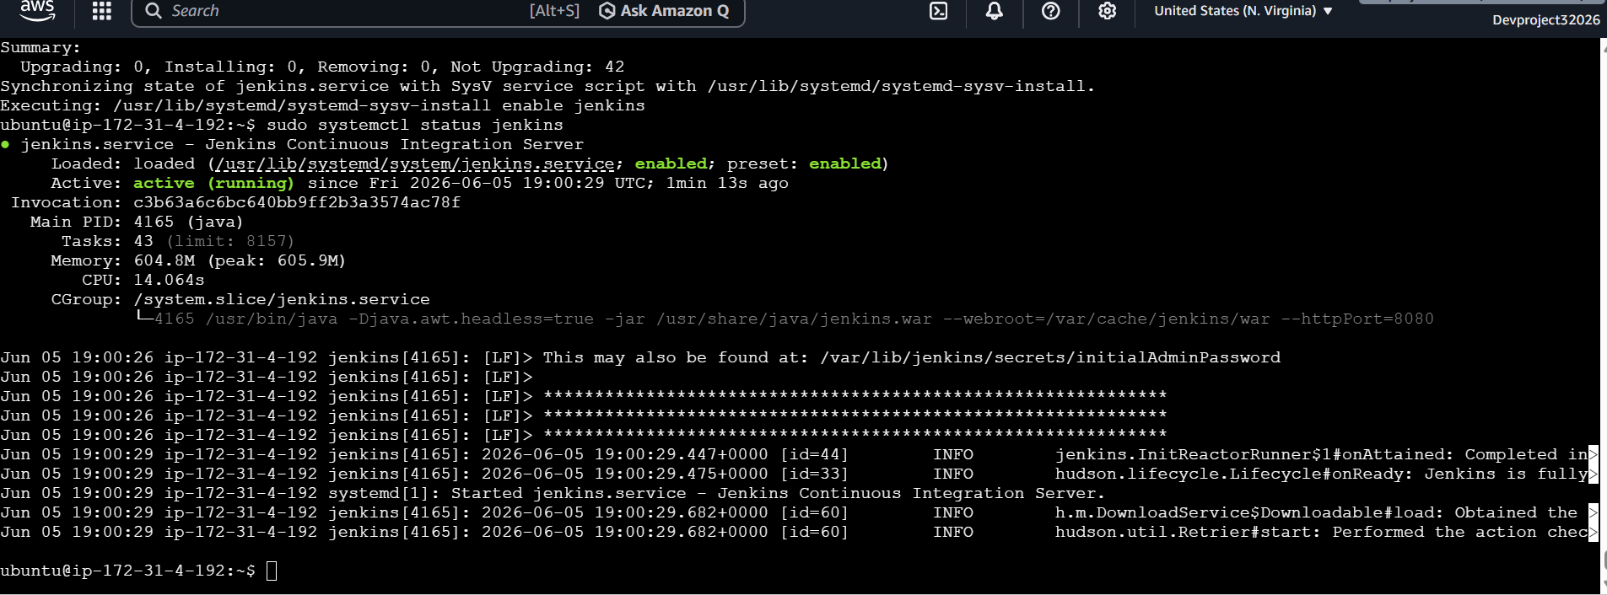
Docker installed & Active

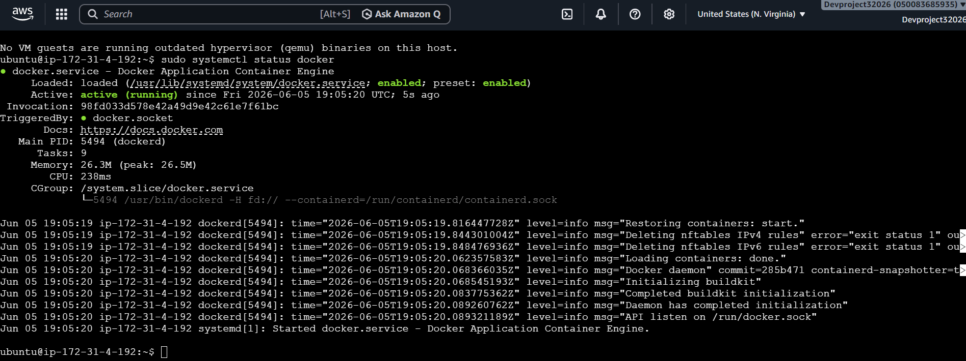
Docker version & docker compose version
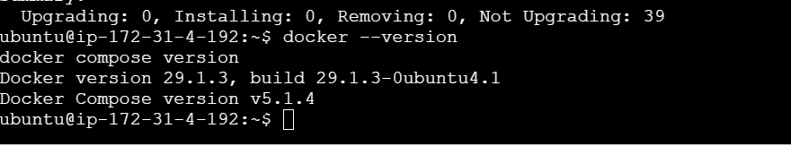
Jenkins Setup

Logged in with IP address using port 8080 & applied password and installed plugged ins & created the user name & password.
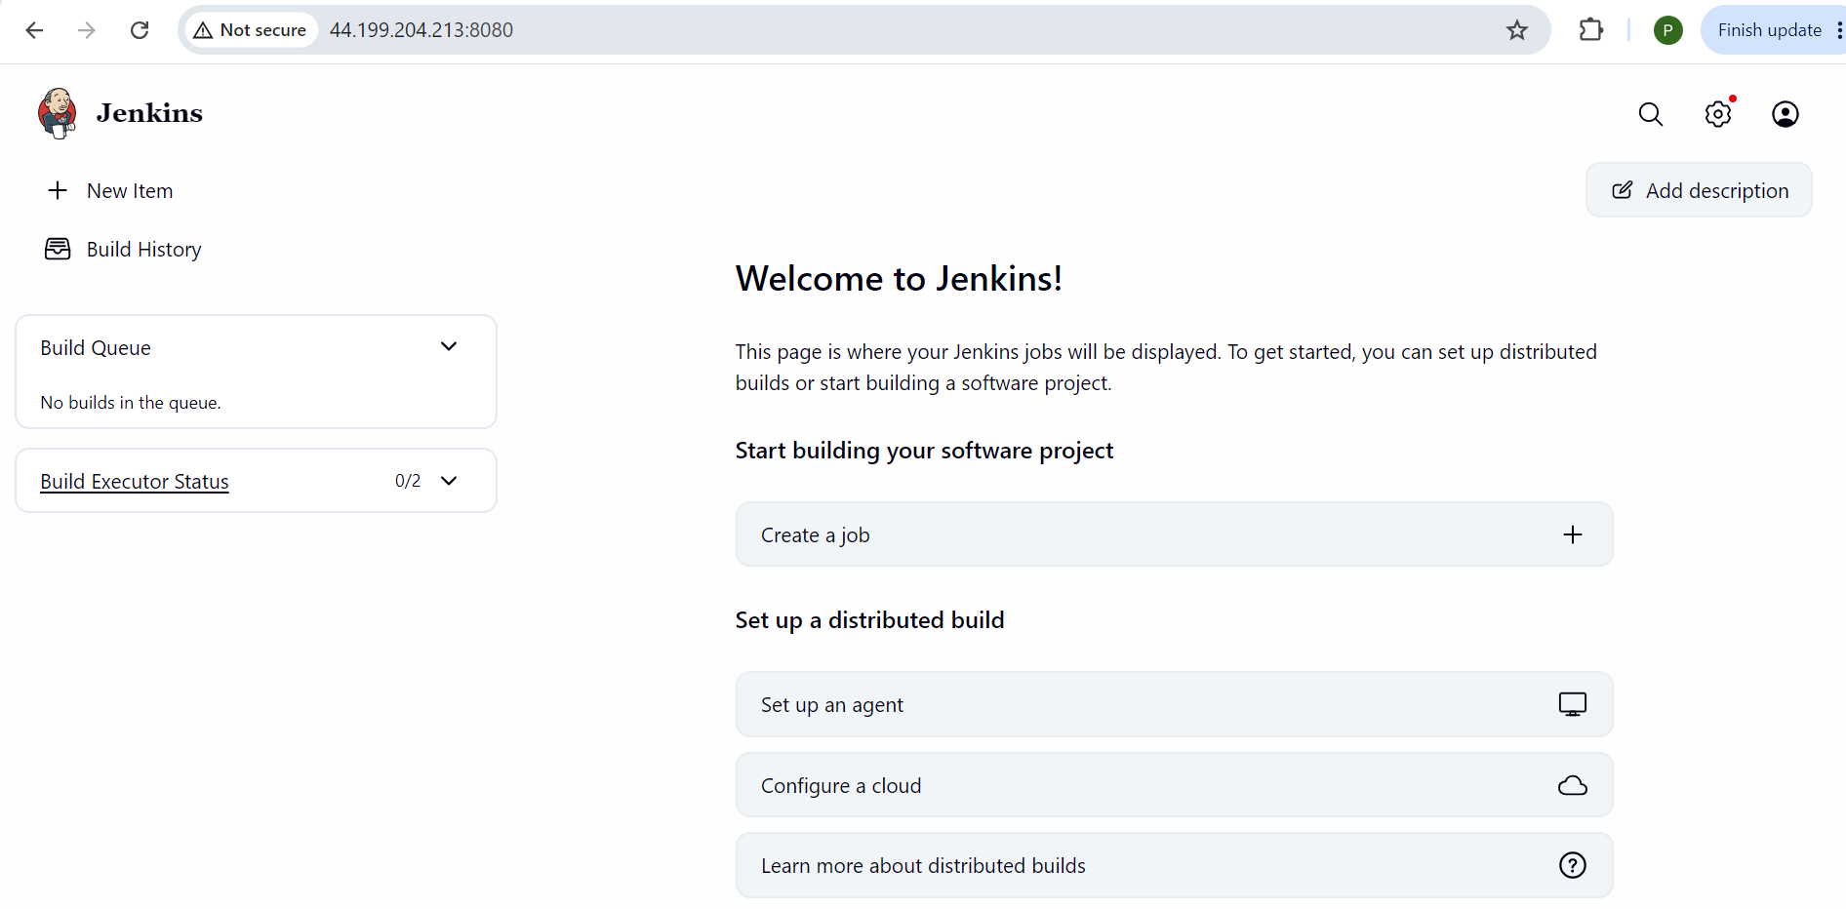
Project cloned

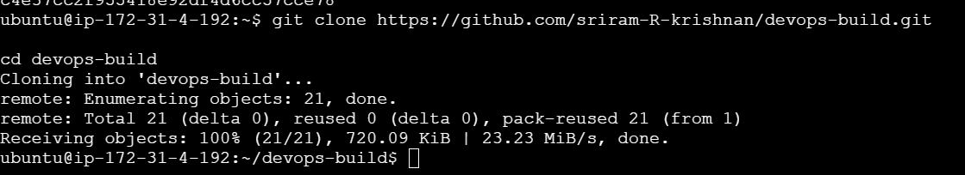
Docker Images
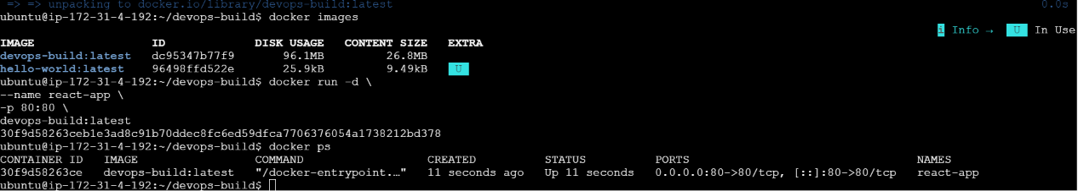

Docker login
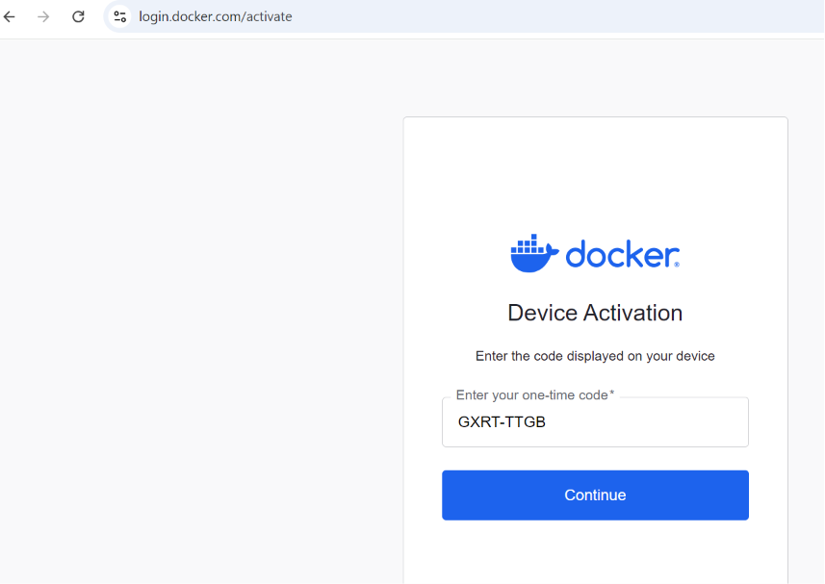

Docker push
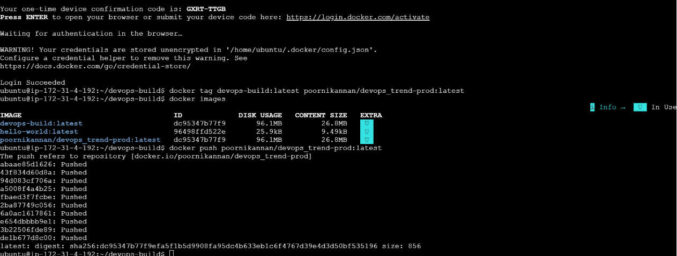

Docker ps
Repo1 image tags
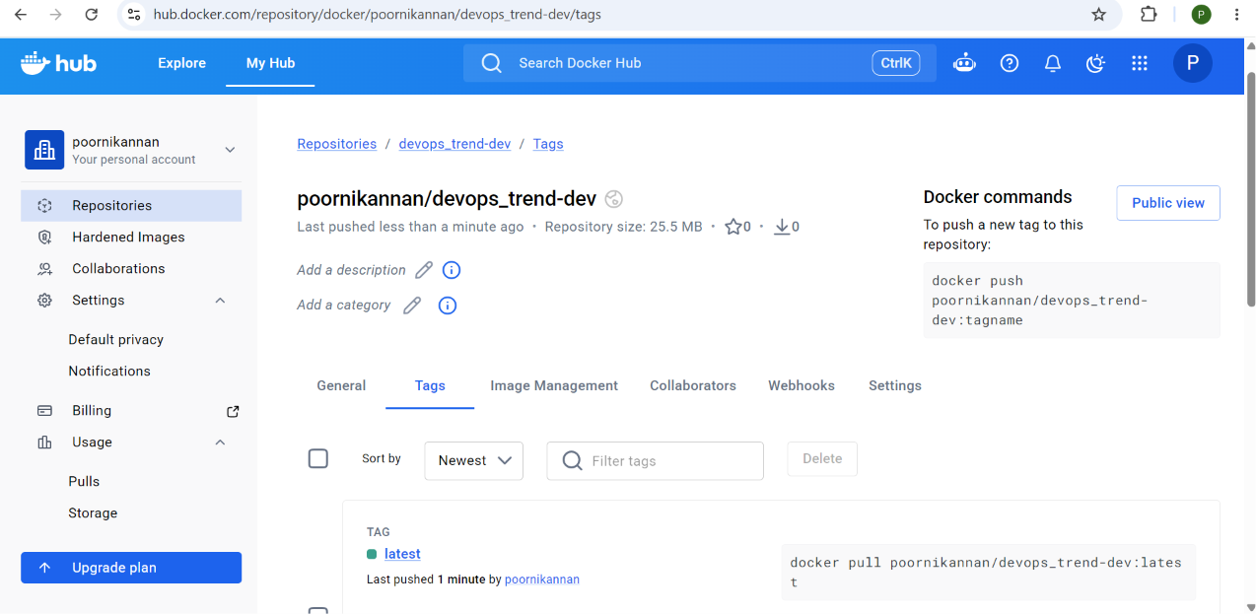
Repo 2 image tags

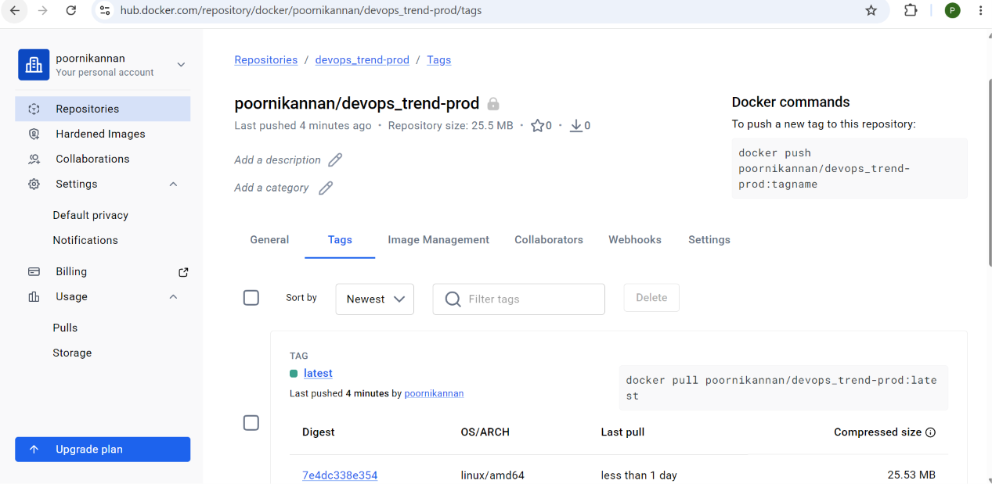

Github authentication
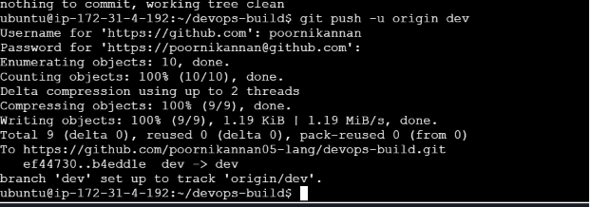

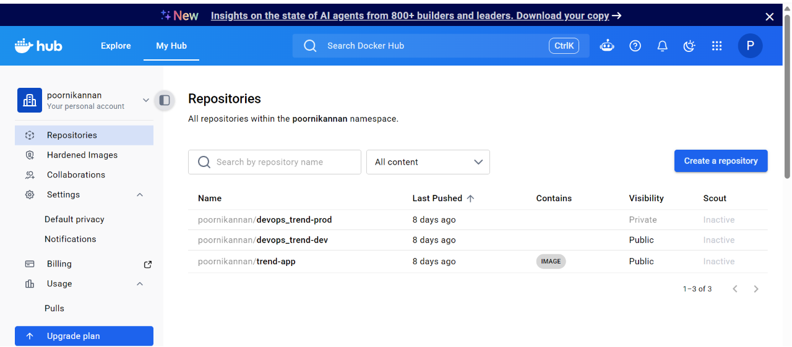
Jenkins
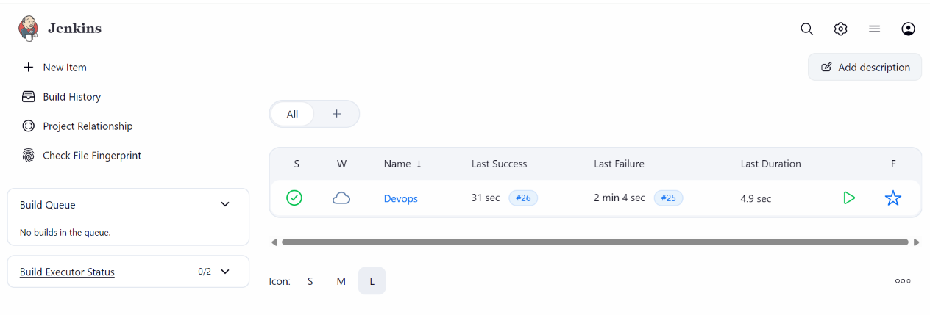
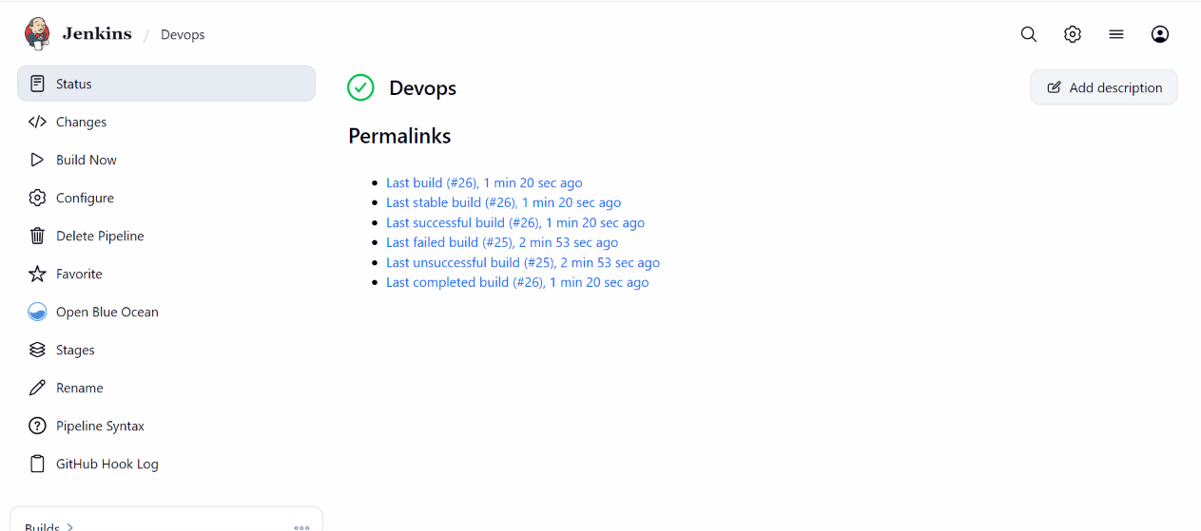
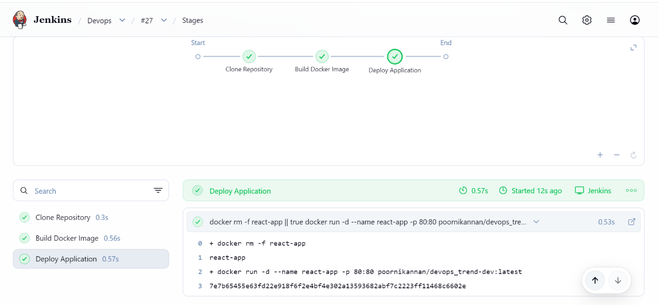

Console output from Jenkins

Started by user poornikannan
[Pipeline] Start of Pipeline
[Pipeline] node
Running on Jenkins in /var/lib/jenkins/workspace/Devops
[Pipeline] {
[Pipeline] withEnv
[Pipeline] {
[Pipeline] stage
[Pipeline] { (Clone Repository)
[Pipeline] git
The recommended git tool is: NONE
No credentials specified
> git rev-parse --resolve-git-dir /var/lib/jenkins/workspace/Devops/.git # timeout=10
Fetching changes from the remote Git repository
> git config remote.origin.url https://github.com/poornikannan05-lang/devops-build.git # timeout=10
Fetching upstream changes from https://github.com/poornikannan05-lang/devops-build.git
> git --version # timeout=10
> git --version # 'git version 2.53.0'
> git fetch --tags --force --progress -- https://github.com/poornikannan05-lang/devops-build.git +refs/heads/*:refs/remotes/origin/* # timeout=10
> git rev-parse refs/remotes/origin/main^{commit} # timeout=10
Checking out Revision 5c447d977ad82600123b44ae5b6d29f506cf3aba (refs/remotes/origin/main)
> git config core.sparsecheckout # timeout=10
> git checkout -f 5c447d977ad82600123b44ae5b6d29f506cf3aba # timeout=10
> git branch -a -v --no-abbrev # timeout=10
> git branch -D main # timeout=10
> git checkout -b main 5c447d977ad82600123b44ae5b6d29f506cf3aba # timeout=10
Commit message: "Create build.sh"
> git rev-list --no-walk 5c447d977ad82600123b44ae5b6d29f506cf3aba # timeout=10
[Pipeline] }
[Pipeline] // stage
[Pipeline] stage
[Pipeline] { (Build Docker Image)
[Pipeline] sh
+ docker build -t devops-build:latest .
#0 building with "default" instance using docker driver

#1 [internal] load build definition from Dockerfile
#1 transferring dockerfile: 137B done
#1 DONE 0.0s

#2 [auth] library/nginx:pull token for registry-1.docker.io
#2 DONE 0.0s

#3 [internal] load metadata for docker.io/library/nginx:alpine
#3 DONE 0.2s

#4 [internal] load .dockerignore
#4 transferring context: 2B done
#4 DONE 0.0s

#5 [internal] load build context
#5 transferring context: 837B done
#5 DONE 0.0s

#6 [1/2] FROM docker.io/library/nginx:alpine@sha256:8b1e78743a03dbb2c95171cc58639fef29abc8816598e27fb910ed2e621e589a
#6 resolve docker.io/library/nginx:alpine@sha256:8b1e78743a03dbb2c95171cc58639fef29abc8816598e27fb910ed2e621e589a 0.0s done
#6 DONE 0.0s

#7 [2/2] COPY build/ /usr/share/nginx/html
#7 CACHED

#8 exporting to image
#8 exporting layers done
#8 exporting manifest sha256:03b1a7708982e4099fa52a8e3490c50281bfbfe960acbff492eb95266b836e7b done
#8 exporting config sha256:6b84779a3725b0c8c560a270360e12d4a25980f68441e3f3924cd289eecac281 done
#8 exporting attestation manifest sha256:98697bef8c56fbcba445e89ba970906ea1b99cdefb6fa6ab597a8210c24751df 0.0s done
#8 exporting manifest list sha256:143f7a1910837738d9ba32c95b12e75272748c3ec56baa878ce6fc71153e1882
#8 exporting manifest list sha256:143f7a1910837738d9ba32c95b12e75272748c3ec56baa878ce6fc71153e1882 0.0s done
#8 naming to docker.io/library/devops-build:latest done
#8 unpacking to docker.io/library/devops-build:latest done
#8 DONE 0.1s
[Pipeline] }
[Pipeline] // stage
[Pipeline] stage
[Pipeline] { (Deploy Application)
[Pipeline] sh
+ docker rm -f react-app
react-app
+ docker run -d --name react-app -p 80:80 poornikannan/devops_trend-dev:latest
3e5b7cf95897e0a201e984aa481c328ffce7a435aa9c74850aad2f402eb6d848
[Pipeline] }
[Pipeline] // stage
[Pipeline] }
[Pipeline] // withEnv
[Pipeline] }
[Pipeline] // node
[Pipeline] End of Pipeline
Finished: SUCCESS

DEV URL (http://98.86.163.236)
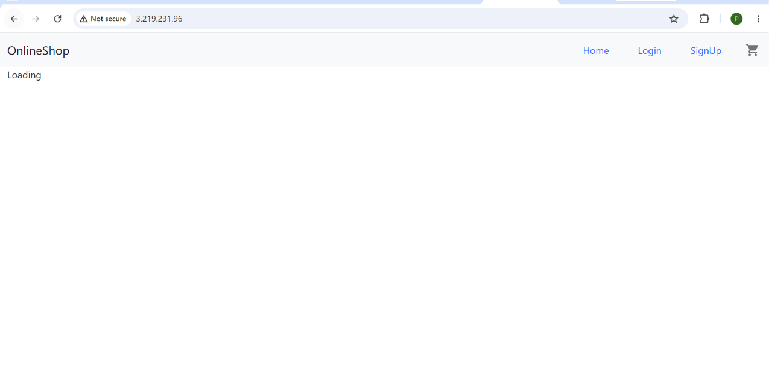

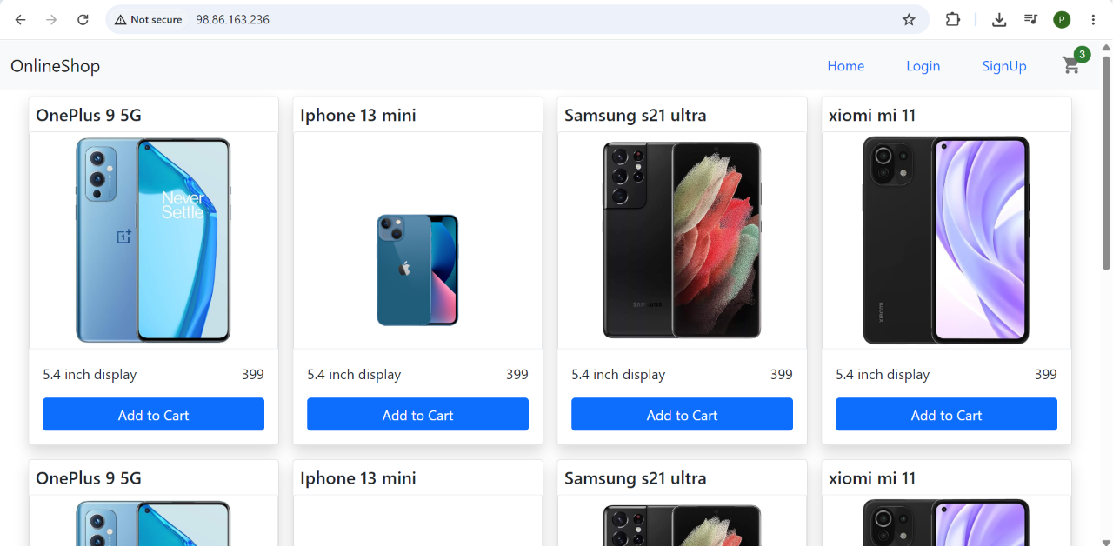

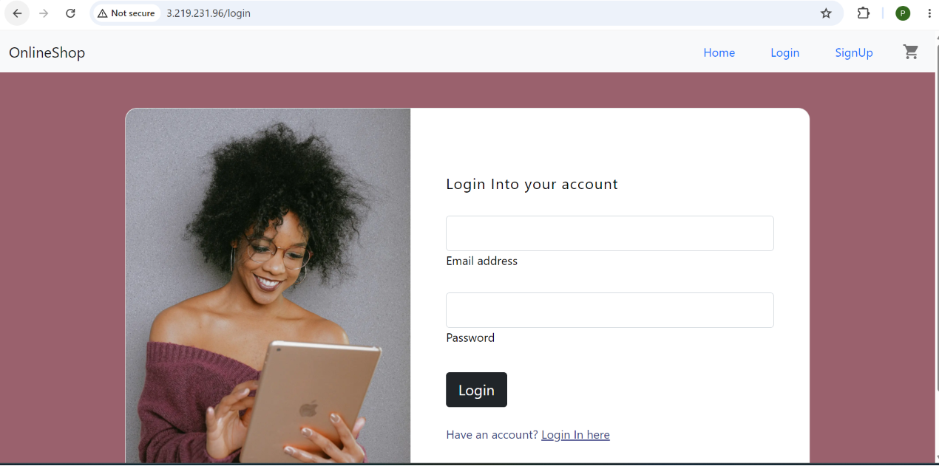
PROD URL (http://98.86.163.236:8081)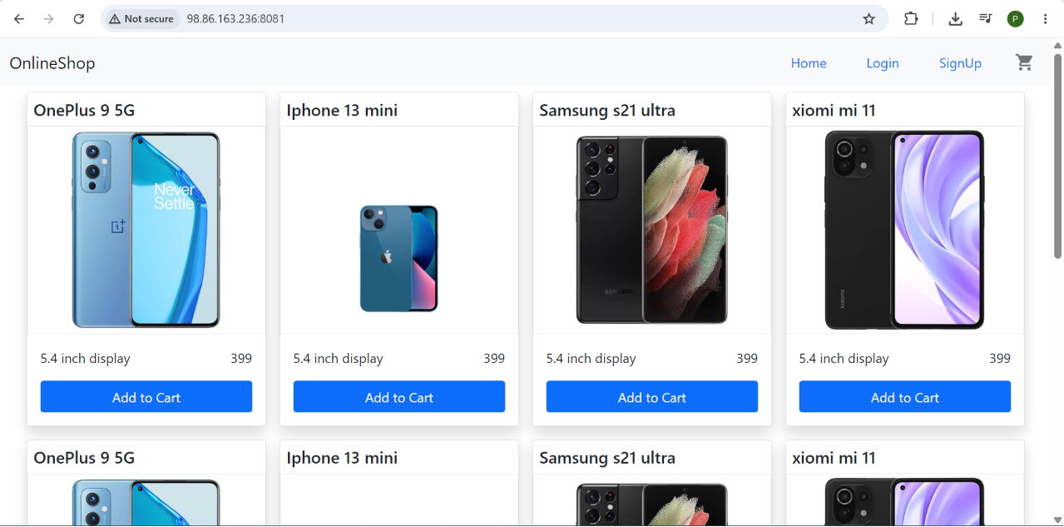

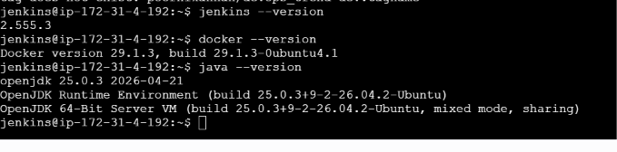
Health Check Output

